Component : This is a basic building block of an Angular application

which means Angular application is a collection of components

A component is a class but with collection of HTML view , style , logic

Its nothing but a class which is differentiated by a decorator

ng g c new-comp

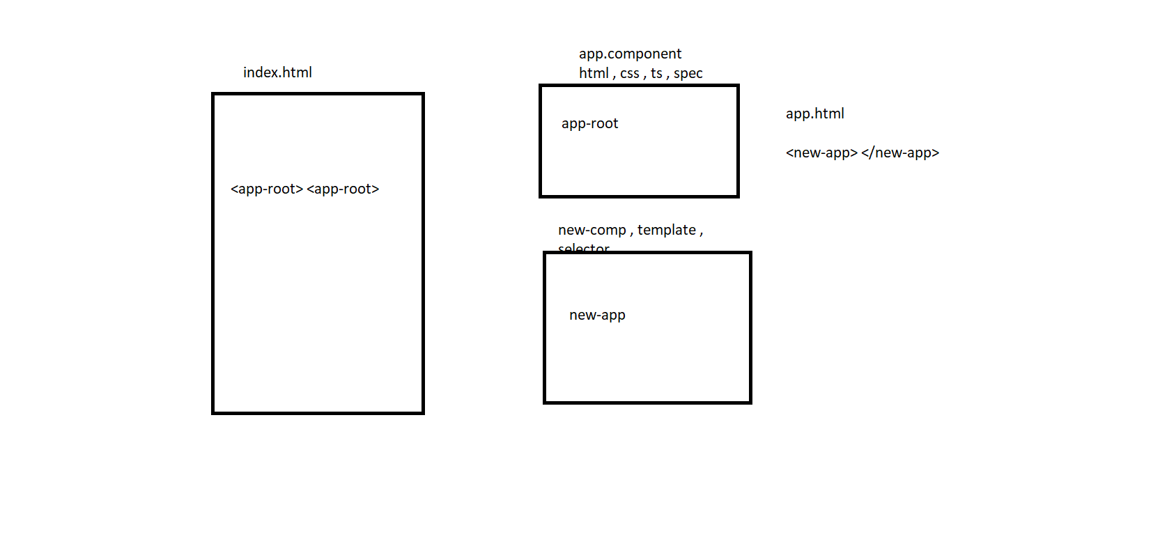

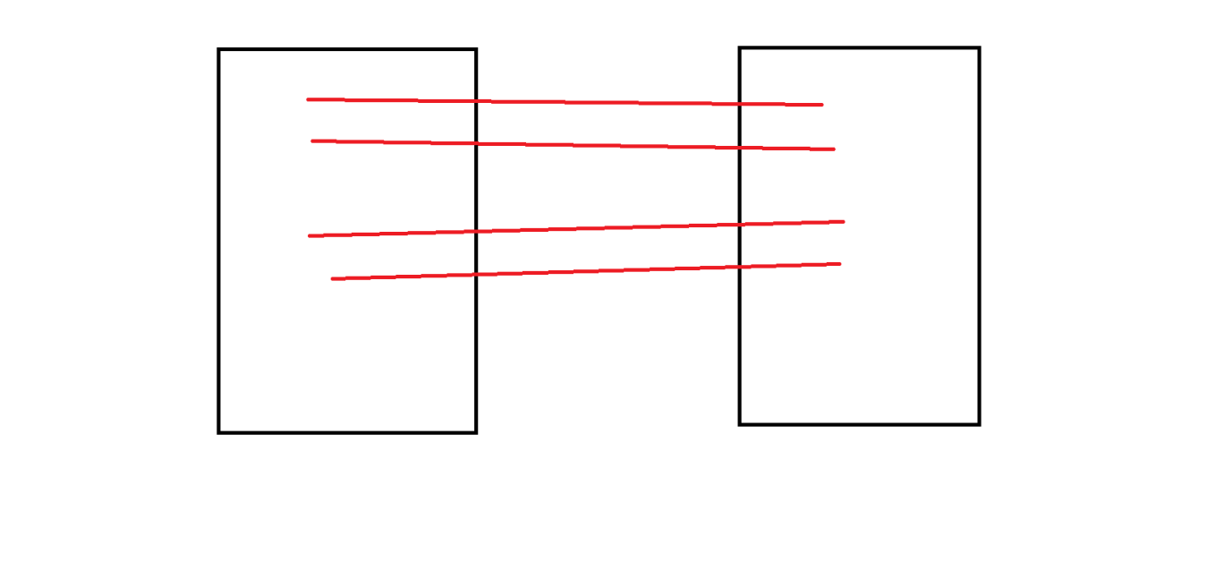

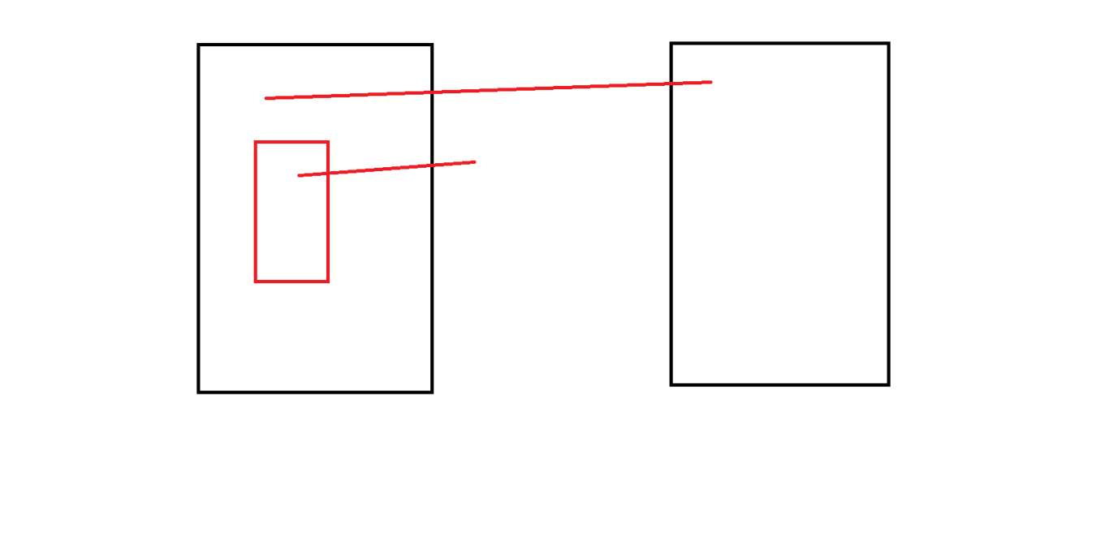

ng g c oo --dry-run

ng g c oo --dry-run --skip-tests

ng g c oo --dry-run --prefix myapp

ng g c oo --dry-run --style scss

ng g c oo --dry-run --style scss --skip-tests

ng g c oo --dry-run --flat

ng g component myfolder/some-name --dry-run